https://doi.org/10.1016/j.rser.2017.04.112 - paper motivated by the demand for new cooling methods as traditional methods fall short in the context of emerging electronics and technology. Centered around high-performance electronics but can still be helpful in determining common cooling methods and problems with such methods.

Two main problems:
- Non-adequate removal of increased heat flux
- Highly non-uniform power dissipation

Why are these problems for us?:
- The failure rate of electronics increases exponentially as operating temperature increases.
- This failure rate can be halved for every 10 degree C reduction in junction temperature and the cooler a device operates, the more reliable it is.
- If heat is not adequately removed, the failure factor of our ROV will be high.
- Thus, it is necessary for the longevity of our ROV to implement adequate cooling.

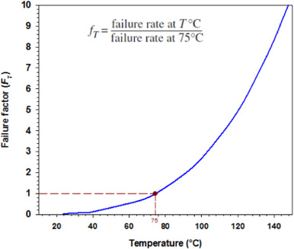

Traditional Cooling Methods
- Radiation and free-convection
  - While the least effective cooling method of those listed here, it is often a very popular choice for low heat flux applications due to its low cost, simplicity, and reliability
  - Heat transfer between a solid surface and a fluid caused by the natural movement of the fluid due to density differences which arise from temperature variations.
  - This will likely be the most probable solution for thermal control, for a heat sink will connect the electrical components to the outside water. Water close to the heatsink will rise away from the ROV, while cold water will fall towards the ROV to absorb more heat.
- Liquid evaporation
  - Generally the most effective of traditional cooling methods
  - Works by turning water into vapor which moves heat away from the surface. This vapor can be condensed back down and reused using a heat pipe or other method.
  - Ideal for high heat flux applications but not for small electronics.
- Forced convection (forced air-cooling and forced liquid-cooling)
  - Forced convection is defined as the process where a fluid is displaced and accelerated by external forces, such as wind or artificial means, resulting in an increased rate of heat transfer.
  - Typically, electronic components will be attached to an external heat-sink or cold plate, which is cooled by forced convection of air or fluid.
  - While adequate for moderate performance electronics, air, water, and oils inherently have poor heat-transfer properties like thermal conductivity and convective heat transfer coefficient.
  - Forced liquid convection is typically more effective than air convection because liquids have a higher heat transfer than air, although much variability exists because type of fluid is also important

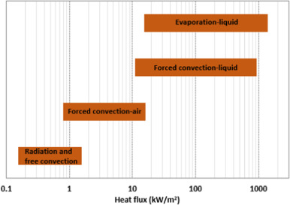

Summary table:

Cooling Tech | Main Features | Advantages / Effectiveness | Disadvantages / Limitations | Cost | Typical Applications
Free convection | – Low heat flux– Passive | – Low cost, simple, reliable– Noise free | – Lowest heat removal– Large surface area needed | Lowest | Small electronics, passive heat sinks, building HVAC
Forced air convection | – Used when free convection insufficient– Fan required | – Well-established, reliable– Widely used in data centers– Low maintenance, simple | – Low HTC– Needs fan– Not noise free | Slightly higher than free convection | PCs, server racks, industrial equipment
Forced liquid convection | – Flowing liquids heated– Pump required– Water common | – Higher HTC than air– Used in commercial exchangers | – Not for small electronics– Fan/pump noise | Higher due to pump, fluids, installation, maintenance | Data centers, high-power electronics, automotive
Liquid evaporation | – Liquid → vapor– Uses enthalpy of vaporization | – Highest HTC & heat removal– Effective in arid climates | – Poor in cold/humid– Not for small electronics– Pressure/temperature fluctuations | High (fluids, heating, installation, maintenance, climate limits) | Power plants, HPC, aerospace
Emerging Cooling Techniques
- Heat pipes
  - Flat heat pipes
  - Cylindrical heat pipes
  - Loop heat pipes
  - Micro-heat pipes
  - Oscillating heat pipes
- Heat pumps
- Microchannels
- Spray cooling
- Phase change material (PCM) cooling
- Free cooling
- Thermoelectric cooling

Improvements
- Nanofluids
  - Newer class of heat transfer fluids which exhibit better heat transfer characteristics as opposed to traditional fluids.

*Insight thus far is that emerging cooling techniques are primarily being pushed for cutting-edge performance electronics. Existing methods will likely be sufficient for our ROV, but innovation could come from how exactly we apply such methods. For example, water cooling may be the most cooling we will ever need, but how can we maximize the effectiveness of water cooling components?

https://doi.org/10.23919/OCEANS40490.2019.8962540 - This paper explores techniques more relevant to our specific use case. It discusses a cooling method used in underwater ROVs as well as alternatives when high performance cooling is unnecessary.

Convection - method of cooling where heat is transferred away from an object due to temperature differences in fluid (hot fluids expand and rise away).

Conduction - method of cooling where heat is transferred away from an object via contact with another object.
- Endcap mounting, shoe-type arrangements, and plate mounting.
  - “One inconvenience in cap mounting is the required landing space, where portions of the endcap cannot be used for connectors. Spring shoe-type heat sinks can add cost because of precision machining requirements of complex geometries and weight, only to suffer noncontact due to maximum deflection caused by high pressure at depth. The heat sink shoes become heat capacitors.”
  - Wall thickness and material resistance are limiting factors

Radiation - method of heat transfer where electromagnetic radiation travels away from the object without a medium (sun to earth).
- Very rarely a relevant factor for electronics due to surrounding conditions.

Liquid-emersion cooling - combination of conduction and convection
- Electronics are directly submerged in a non-conductive liquid
Phase Change - heat pipes and CoolPlugs operate with phase change
- Exploits heat absorbed during phase change to more efficiently remove heat from a system.
- Heat is transferred to a liquid which is then converted to a vapor
- Vapor is condensed back down for re-circulation
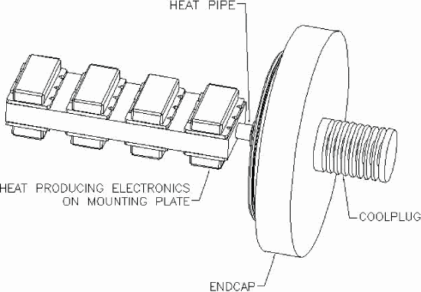
- “Heat pipes reduce mass and thermal inertia over conventional heat sinks because of their light weight and exceptional response time. Weight savings and volume gains could be seen in existing designs, and packaging size reduction in new designs.”
- Revisit paper for more specific information on how the product works from a technical perspective

Heat Pipe Benefits

Feature | Heat Pipes | Traditional Air/Conduction Cooling
Heat transport rate | Very high, can move hundreds of watts over short distances | Limited by material conductivity (metal) and airflow
Temperature uniformity | Nearly isothermal along the pipe | Hot spots occur at high-power areas
Efficiency | Uses latent heat of phase change → much more heat per unit mass | Only sensible heat → smaller heat removal per unit mass
Size/weight | Compact, lightweight | Often requires large metal blocks or fans
Orientation | Works in any direction (with proper wick design) | Airflow-dependent; conduction limited by geometry

